Suhas Dhar

700# = 700721985

Git hub link for first 9 questions:

https://github.com/suhasdhar/Python_basics/blob/main/Assignment1%20ML.ipynb

Question 10:

The diagram below shows a dataset with 2 classes and 8 data points, each with only one feature value, labeled f. Note that there are two data points with the same feature value of 6. These are shown as two x’s one above the other.

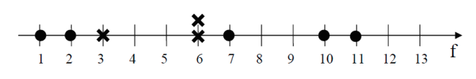

Divide this data equally into two parts. Use first part as training and second part as testing. Using KNN classifier, for K=3, what would be the predicted outputs for the test samples? Show how you arrived at your answer. 2. Compute the confusion matrix for this and calculate accuracy, sensitivity, and specificity values.

**Training data set:**

|  |  |  |
| --- | --- | --- |
| Number | frequency | Result |
| 1 | 1 | 0 |
| 2 | 1 | 0 |
| 3 | 1 | X |
| 4 | 0 |  |
| 5 | 0 |  |
| 6 | 1 | X |
| 10 | 1 | 0 |

**Testing data set:**

|  |  |
| --- | --- |
| Number | frequency |
| 6 | 1 |
| 7 | 1 |
| 8 | 0 |
| 9 | 0 |
| 11 | 1 |
| 12 | 0 |
| 13 | 0 |

K value=3

Nearest values for test data

6 -> 6, 3, 1 : value of KNN = X

7 -> 6, 6, 10 : value of KNN = X

11-> 10, 6 , 7 : value of KNN = X

2. Compute the confusion matrix for this and calculate accuracy, sensitivity, and specificity values.

|  |  |  |
| --- | --- | --- |
|  | Prediction | |
| Actual | X (3) | O (0) |
| (X)1 | True X (1) | False O (0) |
| (O)2 | False X (2) | True O (0)_ |

calculate accuracy, sensitivity, and specificity values:

**Accuracy** : (TP+TN)/(P+N) => (True X +True O)/Actual(X+O)

=>(1+0)/3 =>33.33%

**Sensitivity**: (TP/P) => (True X)/Actual (X)= 100%

**Specificity: =**  1-Sensitivity =0%